Gachuiro Farmers support Report.
The gachuiro farmer’s project is a project owned by farmers who are Equinox’s immediate neighbors, the members of this group were once employed by the Davis farm and as a token of appreciation they were allocated land neighboring the larger Turaco farm where Equinox is situated.
Equinox horticulture ltd employs over 500 employees, some of these employees come from this neighborhood (Gachuiro). Besides the project described below, the company also supports the community policing initiative that has a station within the Gachuiro area. The project encourages community policing (Nyumba Kumi initiative) and police response during incidents. This has helped greatly in reducing the crime rate in the region and also encouraging youths to engage in productive activities.
The residents of this area constructed an intake on the Ontulili River which is regulated by the Water Resource Management Authority for their piped water solution, the problem with this project is that water is rationed and when drought strikes the water taps run dry forcing the residents including the aged to walk long distances to the Ontulili River to fetch drinking water. When the drought persist and during the off rain season (December – March) the river dries up due to persistent farming activities up hill and water flowing down stream reduces greatly. For this reason, the residents are left struggling to access clean drinking water, the Gachuiro farmer’s project in search for a solution to this perennial problem approached the county government of Meru and their problem was given consideration through the county government project to provide clean water to schools and the entire community.
The county government of Meru sank a borehole at one of the community schools situated a few kilometres from Mathagiro Centre and left the residents to decide how they would access the water. On evaluation the members decided that the solution would be for them to purchase water connection and storage items for the community to access this water through a piped system. The community project committee came up with a budget estimate for materials required to pipe this water, unfortunately the majority members of the community are low income earners meaning that they were not in a position to raise the monies required to fund this project.
The project committee members met again to seek a solution to the money problem, they agreed to seek support from neighbors i.e. employers and friends. They approached Equinox Horticulture with a detailed proposal of the projects’ expectations and the benefits to be accrued by the community. When the proposal was received, it was reviewed and approved at 50% of the proposed budget which the committee appreciated and the materials were purchased prioritizing those items that would seem more difficult for the farmers to acquire on their own.
Below is the total budget proposed against the approved budget.
Gachuiro Farmers Project proposed budget
Item | Quantity | Description | Cost per unit | Total cost | 50%
PVC Pipes Class B | 50 | 4" | 1,400.00 | 70,000.00
PVC Pipes Class B | 100 | 3" | 1,130.00 | 113,000.00
PVC Pipes Class B | 235 | 2" | 530.00 | 124,550.00
Water tanks | 2 | 10,000L | 80,000.00 | 160,000.00
 |  |  |  | 467,550.00 | 233,775.00
Gachuiro Farmers Project approved budget
Item | Quantity | Description | Cost per unit | Total cost
PVC Pipes Class B | 50 | 4" | 1350 | 67,500.00
PVC Pipes Class B | 100 | 3" | 595 | 59,500.00
PVC Pipes Class B | 59 | 2" | 450 | 26,550.00
Water tanks | 1 | 10,000L | 63595 | 63,595.00
Gate valve | 1 |  | 16395 | 16,395.00
 |  |  |  | 233,540.00

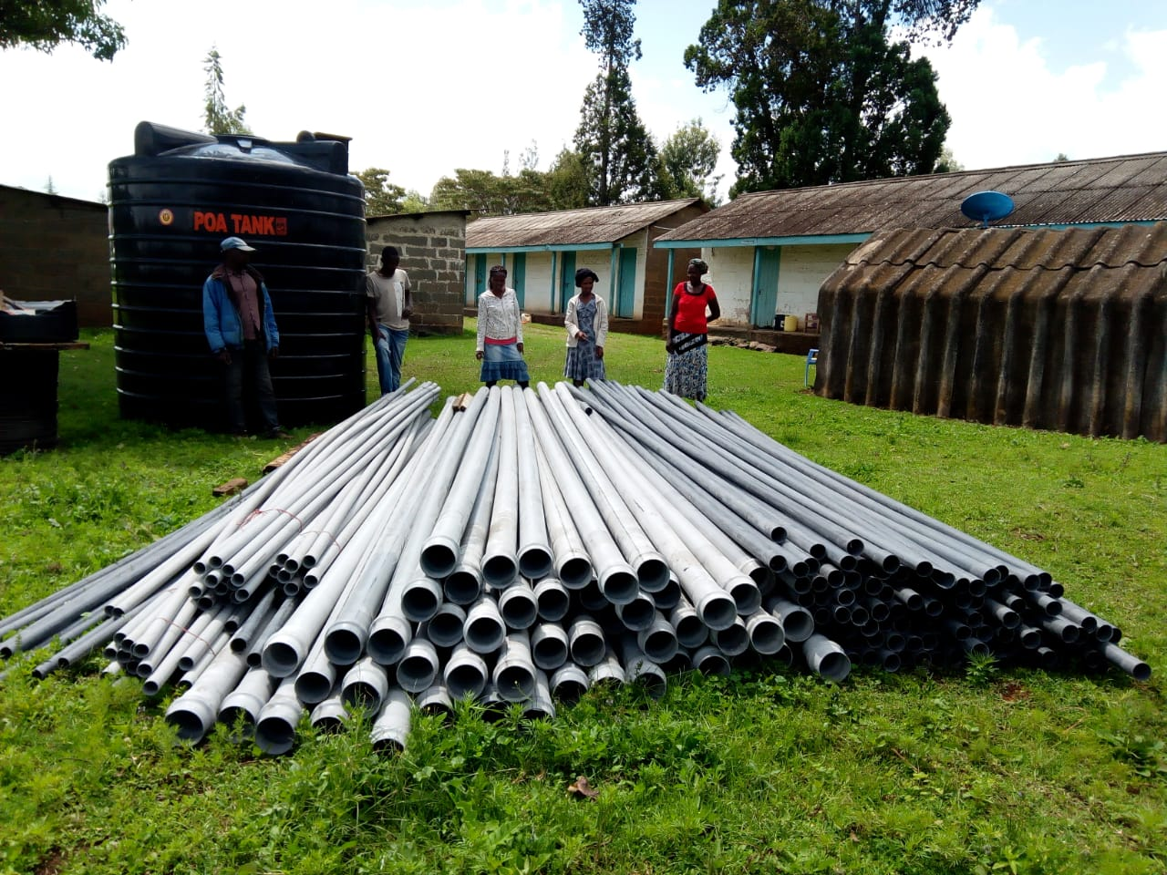
The items were brought in and delivered in a timely fashion considering the urgency of the matter.
Items delivered at the Gachuiro Patrol base.

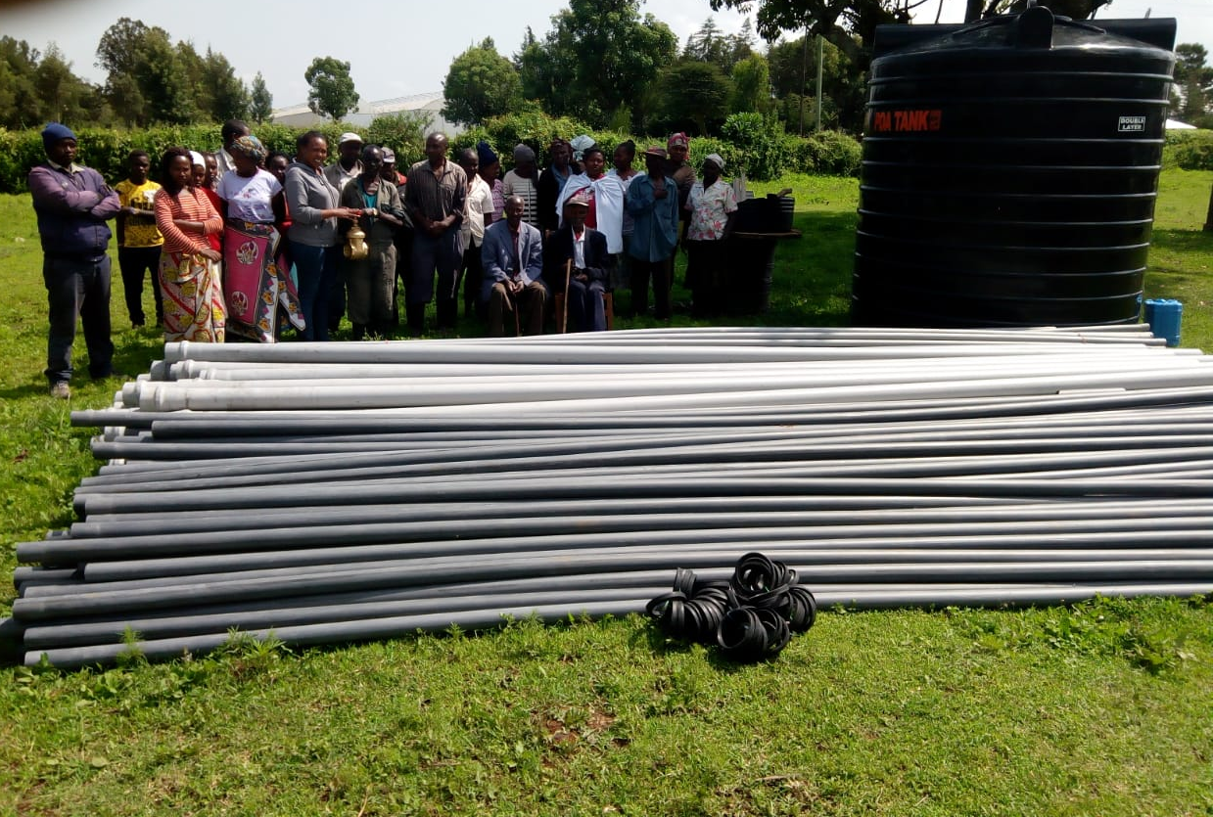
The materials were presented to the committee and members of the Gachuiro at the Gachuiro Patrol base (Timau community policing base) as illustrated here below;

The community receiving the items from Equinox Management
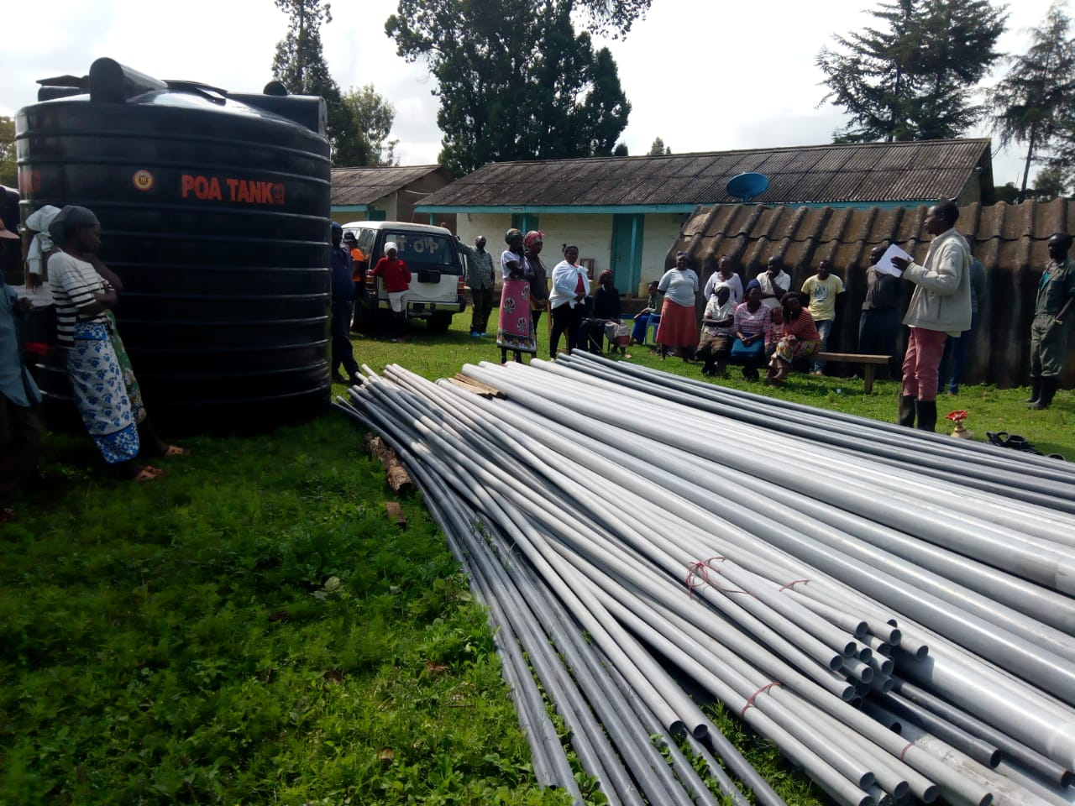
A community member thanking Equinox Management for the support;
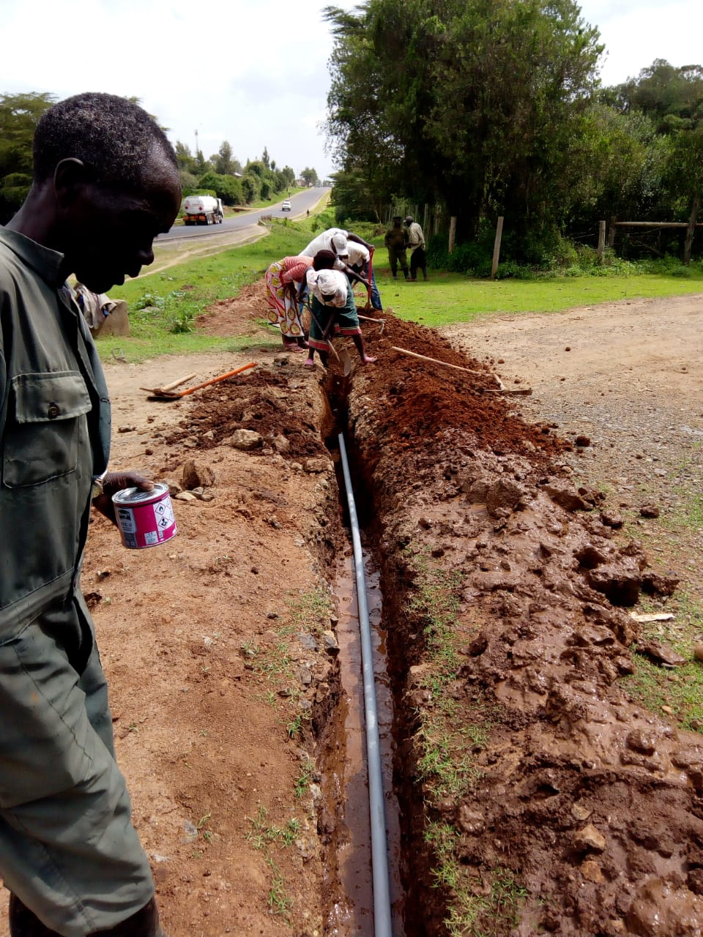
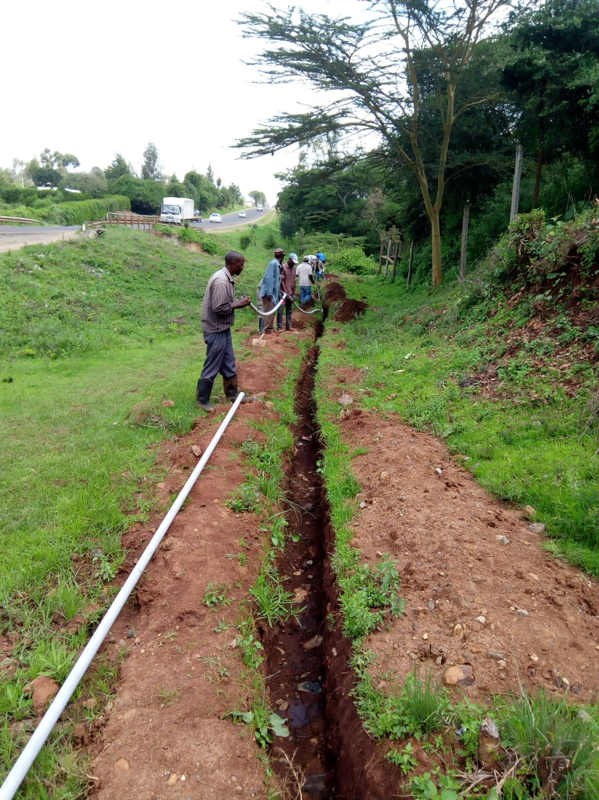
The community actively working to fix the pipes;

