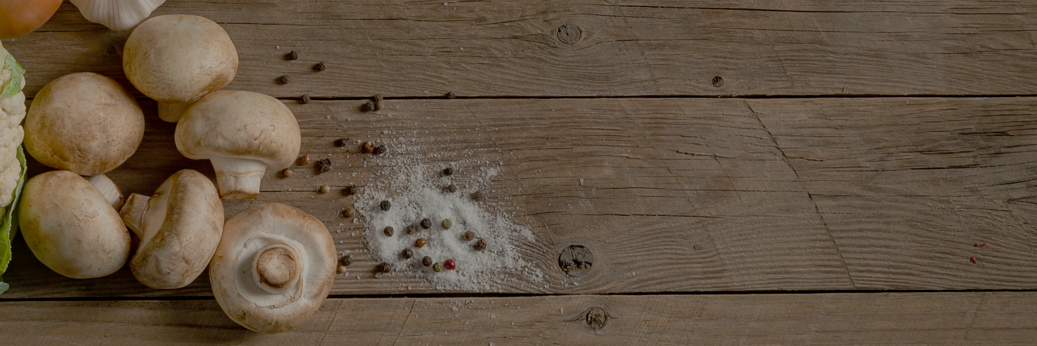
VACUUM COOLING
BETTER SHELF LIFE & PROFITS FOR MUSHROOM GROWERS

WeberCooling is a worldwide leader in Vacuum Cooling Technology. In the past few years more and more systems have been installed at mushroom farms using vacuum cooling as a rapid cooling method for mushrooms. Having the correct cooling processes in place is important in the handling of any fresh produce but for mushrooms it can be even more critical. While consumer demand for nutritious and delicious mushrooms continues to grow, the popular fungi present particular challenges for growers because of their shorter shelf life compared to other produce. Once harvested, mushrooms are highly susceptible to bacteria growth. They can dehydrate and deteriorate rapidly unless quickly cooled and maintained at the correct storage temperature. Vacuum cooling offers here the best solution to growers allowing them to more efficiently cool mushrooms.

The importance of proper temperature and moisture control plays a key role after harvesting the mushrooms, ensuring adequate quality and longer shelf life.

The importance of pre-cooling
Pre-cooling refers to the rapid removal of field heat (normally around 80 – 85%) shortly after the harvest of a crop. Field heat can be defined as the difference in temperature between the temperature of the crop harvested and the optimal storage temperature of that product.
Precooling is a very important step in the post-harvest stage as mushrooms get intro stress after the cutting process. This results in transpiration (sweating, resulting in loss of weight and in the building of moisture on the skin of the produce) and high respiration (breathing = burning sugars), resulting in loss of life, but at the same time in an increase in product temperature, especially when packed tightly. Mushrooms at 20˚C produce 600 % more heat energy compared to mushrooms at 2˚C! This is why it is critical to get them cooled quickly and correctly.

Both respiration and transpiration can be greatly reduced by pre-cooling. On average both can be reduced by a factor of 4, 5 or even more, if cooled down from harvesting (on average at 20 – 30 ⁰C / 68 – 86 ⁰F down to below 5 ⁰C / 41⁰F). The perfect end temperature is defined by many factors, like produce to be cooled and the post harvesting steps following the pre-cooling.

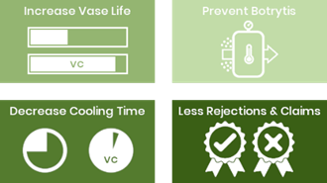
Proper pre-cooling will further:
- reduce rate of ageing, resulting in longer shelf life;
- prevent mushroom browning
- slow the rate of produce decay by slowing or inhibiting microbial growth (fungi and bacteria);
- reduce the rate of ethylene production
- increase market flexibility
- meet customer requirements
Overall it helps to reduce the loss in quality of produce once it’s been harvested. Likewise, precooling increases the shelf-life of fresh produce. Higher quality and longer shelf-life means more profits to mushroom growers.

Pre-cooling methods

2.1 Available pre-cooling methods
There are different alternative methods for pre-cooling of flowers
- Room Cooling (in a conventional cold storage)
There is a trade-off with Room Cooling. It requires relatively low energy but is very slow.
- Forced Air Cooling (or blast air cooling, forcing cold air through your produce)
Forced air will cool faster compared to room cooling, but it will always cool “outside-in” and will reach the core of the product only after long cooling
- Vacuum Cooling uses the boiling energy of water to cool down your produce.
For the water in the product to boil, the pressure in the vacuum room must be brought down to ultra-low pressures. Cooling to the core of the boxes is easy – and fast.

Comparison of pre-cooling methods
The table below compares pre-cooling methods as applied to fresh fruits and vegetables.
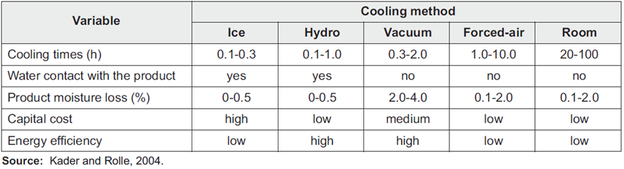
In this document we will tell you more about the technology of Vacuum cooling, the applications and benefits it offers.

Vacuum pre-cooling
By far the most important part of maintaining the quality of harvested mushrooms is ensuring that they are cooled as soon as possible after harvest and that optimum temperatures are maintained during distribution. Mushrooms are usually harvested at relatively high temperatures. As they are living products, they continue to create heat (and moisture). To prevent excessive temperatures, increase shelf life, reduce rejects and achievable prolonged shipping times, quick pre-cooling right after harvesting or packing is vital.
Vacuum cooling is 5 - 20 times faster and more effective than conventional cooling! Only vacuum cooling can cool ultra-fast and uniformly to the core down to 0 - 5°C for most produce within 15 - 20 minutes! The more surface the produce has related to its weight, the faster it can cool, providing you have chosen the right vacuum cooler: depending on the desired end temperature, mushrooms can be cooled between 15 - 25 minutes.
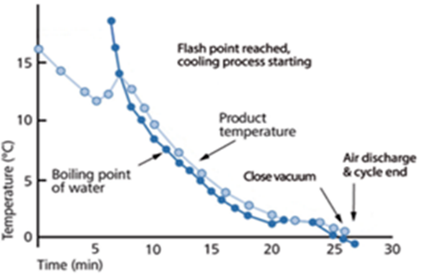
The final cooling temperature plays an important role in the time to cool. The first stage of cooling, down to around 5⁰C, is always very fast (providing the vacuum cooler is fast enough), but cooling down to around freezing temperatures requires much more time, as the graph shows.
Other advantages of vacuum cooling methods include that paper and plastic packaging materials in the boxes do not affect the efficiency of cooling, free water is removed, boxes can be packed tightly and stacked in any manner in the pre-cooler.

Vacuum Cooling Technology Explained
Pressure - Water boiling temp.
mBar | °F | °C
1000 | 212.00 | 100.0
56.2 | 95 | 35
42.4 | 86 | 30
31.7 | 77 | 25
28.4 | 68 | 20
20.6 | 64.4 | 18
18.2 | 60.8 | 16
17.0 | 59 | 15
16.0 | 57.2 | 14
15.0 | 55.4 | 13
14.0 | 53.6 | 12
13.1 | 51.8 | 11
12.3 | 48.2 | 9
10.7 | 46.4 | 8
10.0 | 44.6 | 7
9.3 | 42.8 | 6
8.7 | 41 | 5
8.1 | 39.2 | 4
7.6 | 37.4 | 3
7.1 | 35.6 | 2
6.6 | 33.8 | 1
6.1 | 32 | 0

Vacuum works with pressure. There is a relation between the pressure level and the boiling point of water. The lower the pressure, the lower the boiling point of water. When introducing a product recently harvested into the vacuum room, vacuum pumps start evacuating much of the air lowering the pressure inside the room. When the pressure level reaches the product’s temperature, a fraction (0,8 – 2%) of the moisture inside the product is being forced to evaporate. This evaporation process extracts energy (=heat) from the product, cooling the in- and outside of the product evenly, from the core. Because of the created vacuum, not only the outside is cooled down, but the product's core as well, as cooling takes place from inside the product.
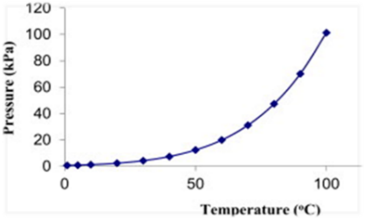
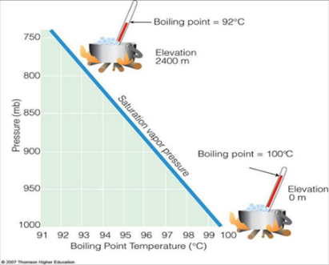

Vapor flow at final pressure is huge and would require very big vacuum pumps. Using a condenser to trap the vapor flow is more economical! Weber Cooling vacuum coolers operate with very efficient condensers using glycol/water coolant (-5 to -0°C) for a fast cooling. The hot vapor passes through the heat exchanger through which it is re-condensed and drained out of the room. When the cycle is finished, vacuum pumps pump air into the room and the door can be opened again.
Note: For every 6-7°C reduction in temperature, approximately 1% of the produce weight needs to be turned into water vapor. In an average cycle of 15-25 minutes, weight loss can vary between 2-3%.
1. The product is placed in the vacuum room and room is closed. | 2. The vacuum pump starts and reduces the air pressure in the room from 1000 mbar to the desired pressure.
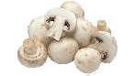
3. A small amount of water within the product will start boiling when pressure reaches temperature level of the product. This boiling process requires heat that is extracted from the product, enabling the cooling. | 4. In the condenser (located in the room) the water vapor is re-condensed and the vacuum pump extracts the dry air.
5. The cycle ends when the product is cold and the pressure returns to 1000 mbar. | 6. The condensed water is drained and the vacuum cooler is ready for the next load.
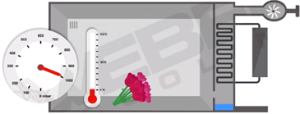 | 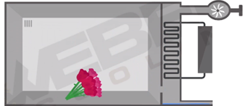

5. Components of a vacuum cooler
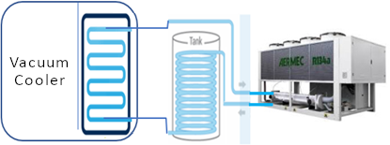

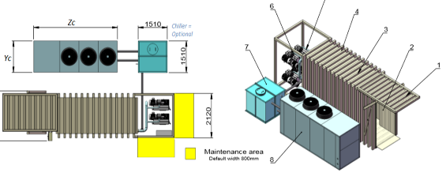

6. Energy consumption
There is no discussion about the fact that vacuum cooling is the most energy efficient method for cooling down mushrooms and can be applied more efficiently than forced air. As a rule of thumb, you can say that due to the difference in energy coefficient, forced air cooling will need up to 4 or 5 times more energy compared to vacuum cooling!

6.1 Energy consumption comparison:
Average precooling efficiency:
- Forced air cooling: 30 – 50%
- Vacuum cooling: 140 –250%

To cool down 100 kg of produce in a vacuum cooler, you will need roughly 1 kWh of energy (+/- 20%), to cool down from 23°C down to 3°C. The energy needed will be lowest for flowers and highest for vegetables & herbs (as they have a higher specific heat). With forced air this can be more than 3 kWh! Beside the energy efficiency of vacuum cooling, it also reduces the energy requirement or workload of a cold store system.

7. The importance of Cold Chain Management for optimal Logistics & Shelf Life
Vacuum cooling is the perfect pre-cooling method for all mushrooms and has been successfully implemented at many mushroom farms. Why is vacuum cooling so perfect?
The technical story:
Vacuum cooling significantly lowers the superoxide generation of mushrooms, which causes many types of cell damage and is associated with the aging process and several diseases of mushrooms. The significant lower number of super-oxides increases shelf life and prolongs freshness and quality.
On top of that, a significant increase of peroxidase activity can be found in mushrooms after vacuum cooling treatment. Peroxidases play an important role in defending against pathogens, having a positive effect on the shelf-life of the mushroom. Vacuum cooling reduces the level of lipid peroxides, thereby reducing cell damage and preventing oxidative injury to the mushrooms.
The practical story:
With vacuum cooling, you can quickly reduce the temperature of mushrooms down to 1 - 3⁰C, to the core, normally within around 15 minutes. This brings the mushroom into hibernation, minimizing respiration & transpiration, preserving freshness and maximizing storage and shelf life. The mushroom stays firm & strong, for longest time.
An additional advantage is that with vacuum cooling you dry the skin; this minimizes the risk of browning. Browning of the mushroom cap, which is the main criterion of quality, can be measured as loss of whiteness using a reflectometer. There is a significant difference in reflectance between vacuum cooled and conventionally cooled mushrooms if the cold chain is broken. Here you see that the vacuum cooled mushrooms remain much less brown than those conventionally cooled, again maximizing storage and shelf life.
The mushroom stays perfectly white or brown.

8. Intermezzo – vacuum cooling of turf & compost
Turf is “harvested” and compost is finished at relatively high temperature: For compost 20 °C is a good average temperature, for turf this can be (much) higher, even up to 30 °C in high summer. As it is a living product, it continues to create heat (and moisture). In order to prevent excess here, and loss of life - and shipping time, quick pre-cooling is very important. Problem is that the produce to be cooled is often very dense and high weight.
Normal cooling methods are not well suited for cooling down. It just takes too much time, uses too much energy, and it is too difficult to really cool to the core, there where heating up starts quickly again if not cooled well!
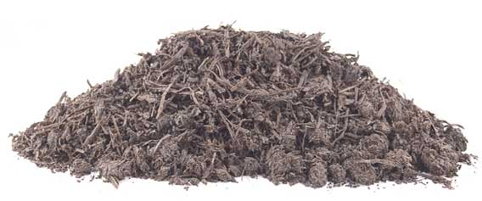
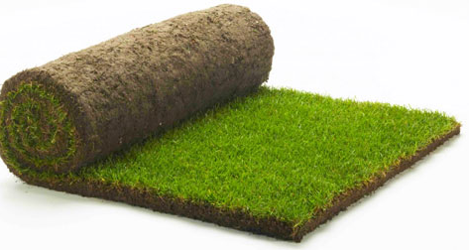
Here vacuum cooling is the only cooling method that can really get to the core of Turf & Compost and is therefore the only solution to really extend the shelf life and transport time. By utilizing vacuum cooling, grass bales and compost can be compactly cooled to near freezing point, putting the product into sleep mode and minimizing respiration and internal heat generation.

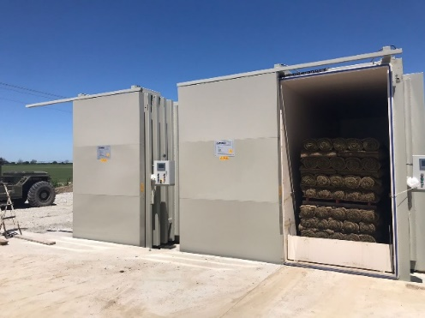
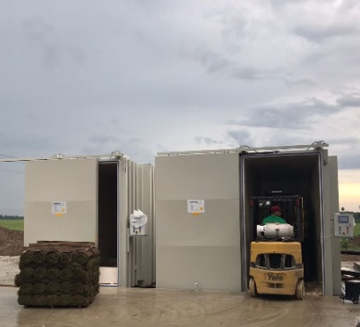
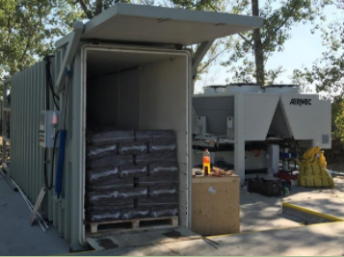
The cooler the product, the lower the activity of the turf / compost, the longer the product itself will remain cold. Storage in the refrigerator or refrigerated transport after cooling is advised to keep the product cool. If pre-cooled quickly and throughout the product, produce quality can be maintained, and storage and shipping times can be substantially prolonged. As well as the processing time on arrival. All parties involved profit by good and fast pre-cooling!

9. Vacuum coolers for Mushroom Farms
As mushrooms have approximately 90% water and the porous structure of the mushroom allows water to escape very readily, they are therefore very suitable for vacuum cooling. Mushrooms have an open structure, allowing for fast vacuum cooling. The perfect vacuum cooler for mushrooms is designed to cool down pallets with on average 200 – 300 kg of mushrooms within 15 minutes, down to 1 … 3 ⁰C.
Smaller farms can work with smaller vacuum coolers; with a one pallet system, you can achieve highest cooling speeds, of 12 – 15 minutes. With the Weber Compact ONE you will cool three to four loads per hour, or up to 32 pallets on an eight-hour working day! Available in different configurations, you will always find a system perfect for you.
With the Weber Compact TWO you will achieve cycle times of around 15 minutes. Including logistics, you will cool up to three loads per hour, or up to 48 pallets on a normal day! Also available in different configurations, you will always find the perfect fit.
The Weber Base Gen & Next Gen models offers standardized solutions for three up to ten Standard pallets (1.000 x 1.200 mm), and for up twelve Euro pallets double rows of Euro pallets (800 x 1.200 mm). It’s easy to achieve a capacity of well over 200 pallets per eight-hour shift. Available with electric sliding or hydraulic swing door – upon your request.
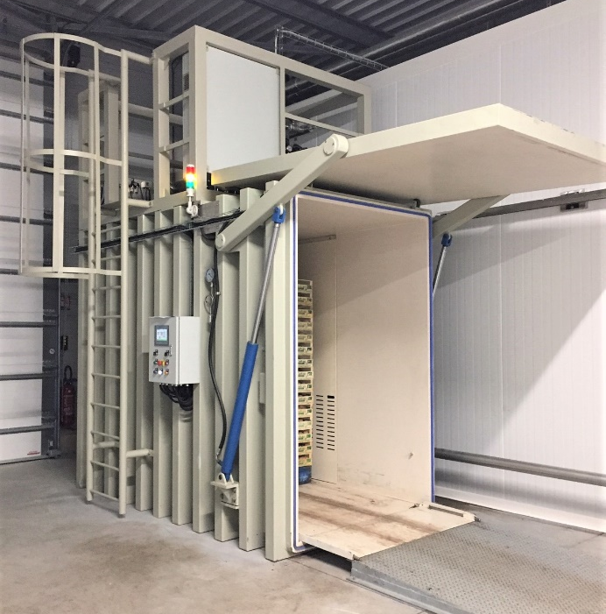
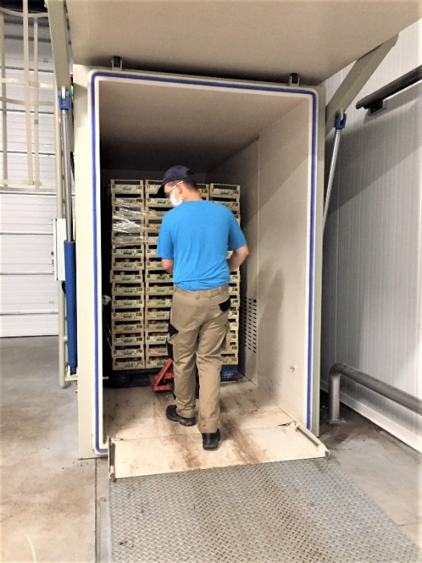
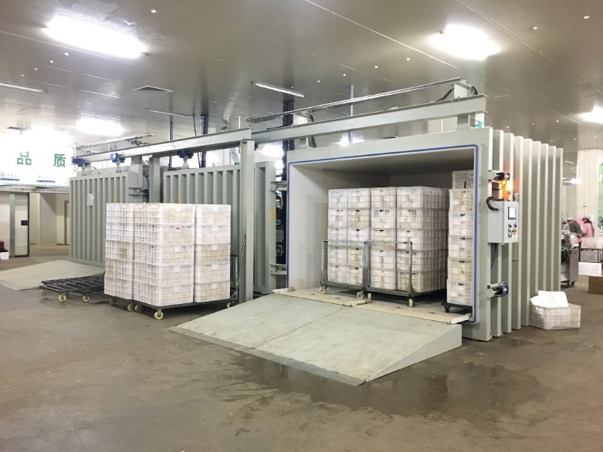
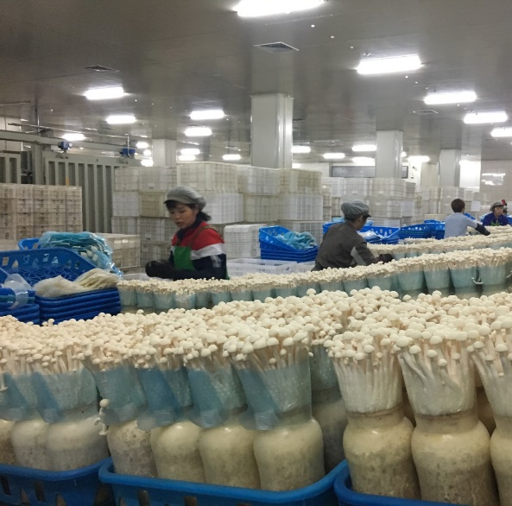
Should you require higher capacities, or have special requirement, we can supply! Some recent examples include multiple room vacuum cooling systems, in standard configuration, and with ultra-wide rooms. We can build solutions for each demand.

10. Weber Cooling – Your First Choice
Weber Cooling only builds vacuum coolers – and makes the best systems you can get. All vacuum coolers are designed by our Dutch engineering team, and build using only premium (European) components. As largest producer in the world, with different production locations, we can offer unparalleled value for money.

Our global presence ensures our availability for maintenance and service worldwide. No other supplier has more knowledge and experience on flower (pre-)cooling than Weber Cooling.

For our Next Gen range we exclusively work using “Hydronic Technology”, with which cooled water (generated by a chiller) is used in a secondary cooling system for the “Cold Wall” inside the vacuum cooler. Hydronic Technology offers many advantages: It gives you faster cooling, it reduces the amount of refrigerant in the system and it minimizes maintenance and TCO.

For our export markets we also offer the conventional Base Gen range, using DX (direct expansion) technology, in which you cool the “Cold Wall” directly with your refrigerant. Simple & effective. Requiring minimum installation, and at lowest cost (especially for smaller systems).

Video’s on vacuum cooling of mushrooms:
https://vimeo.com/168633903
https://vimeo.com/395395314
https://vimeo.com/351377290
https://vimeo.com/showcase/6810108

