**END OF LINE AUTOMATION: GETTING IT RIGHT FIRST TIME**

Whether you’re investing £500,000 or £5 million in a packing automation project, the processes, principles and potential pitfalls are the same. Here, David Jahn, Director at robotic packing systems designer Brillopak, shares his top tips for ensuring that projects run seamlessly from start to finish.

1. Think Partnership

Think of your chosen automation integrator as a ‘partner’ and look at your decision to work together as the start of a long-term relationship. Both parties need to put the effort in. The system you are investing in should last well over 10 years and to get the best return from that investment you need to cultivate mutual trust and work as a team. This means being open about your expectations and limitations from the start to avoid misunderstandings down the line.

2. Take time to plan

Take time to plan your desired solution before placing your order. Any automation supplier worth their salt will want to spend time at the outset understanding all aspects of a project rather than rushing through an order based on incomplete information. Consider the space available, the relationship with other processes, every single SKU and its foibles. Think through and simulate the impact of all potential issues that could occur during production. Then make sure both parties understand the details and challenges before you start.

3. Put it in writing

Use a URS (User Requirement Specification) to ensure that your brief is clear, or ask your supplier to provide a detailed project specification. This helps to clarify exactly what is required from both parties and ensures a mutual understanding and agreement of the solution that is to be implemented.

4. Check before you accept

Before accepting delivery of the system, visit the manufacturer’s site to check it meets your URS. If it doesn’t, don’t accept it! Getting any fixes carried out before the system leaves the supplier’s factory to minimise production downtime. Also, quick fixes that are made on-site in active production areas can be a potential source of future reliability issues.

5. Allow time for installation

Planned downtime is better than unplanned downtime. If you force a fast install, you will lose twice the time in the months that follow fixing bugs that will have arisen through insufficient testing. Agree the time that will be required for installation and plan it into production schedules.

6. Nominate a champion on the ground

Every new automation project needs a champion on the shop floor who will take ownership for making sure the system works on a day-to-day basis. Trained properly, they will become a confident operator and advocate of the technology. Encourage this person to visit the factory to see the machine being built, so that they ‘buy in’ to the project from the start. This resident expert’s engagement will have positive knock-on effects, helping to engender acceptance of the new equipment and contributing to production efficiency by minimising the chance of operator mistakes.

7. Prioritise training

The importance of training for operators and maintenance teams cannot be overstated. Time for training must be scheduled into people’s diaries and honoured - however busy they are. Time invested in training at the outset is recovered over time through increased uptime. Conversely, when people do not fully understand the machine they are working in, the result is increased downtime while they learn on the job by trial and error. During the session itself, keep the group to a size whereby everyone has time on the system and to ask questions.

8. Be prepared with spares

Order sufficient spare parts regardless of whether or not the system is under warranty. That way if there is a crisis and the parts – for whatever reason – are not immediately available from the machinery supplier, you have the capability to get the system up and running again.

9. Keep connected

Set up your system with remote access capabilities. If a new machine develops a fault, or there is a user error that results in line stoppage, this problem quickly becomes ‘historic’ and no-one remembers how or why it happened. Without knowing the root cause, it may arise again. If your automation partner has real-time remote access, they can see everything the operator sees, enabling quick diagnosis and resolution of issues.

10. Expect the unexpected

No matter how carefully a project has been orchestrated, there will always be bolts out of the blue. They may be something no-one has considered during the planning stages, a pack might be out of specification, or the system simply isn’t working as expected. Accept that teething problems may occur – especially with a bespoke build – it is how they are addressed that matters. Make sure you partner a supplier with ‘staying power’, who is committed to working with you in the months and years after installation to overcome technical challenges that nobody could have predicted.

More and more companies are automating packing operations for the first time, because labour is both expensive and scarce. By taking on board these tips, you can get it right first time – avoiding mistakes and misunderstandings that will impact on production efficiency.

**About David Jahn**

|  |  |
| --- | --- |
|  | *Focused on serving the fresh produce sector, David Jahn, co-owner of Brillopak with business partner Peter Newman, is passionate about assisting packhouses to address labour shortages, profitability and operational efficiency.*  *Part entrepreneur, part innovator, part director, David has a good grasp of how economic and political decisions impact business and society globally, particularly in the logistics, manufacturing and packing sectors.*  *Building systems for a diverse client base - including leading UK supermarkets, SME food factories, and contract packers, David gets that no single approach to automation is right for every business or budget. He provides a fresh perspective and insight, applying his previous experience gained from launching a business, being a technology company Board Director and working in risk management consultancy.* |

**Images/Captions**

**Image 1**

More and more companies are automating packing operations for the first time, by taking on board these tips, you can get it right first time – avoiding costly mistakes and misunderstandings that will impact on production efficiency.

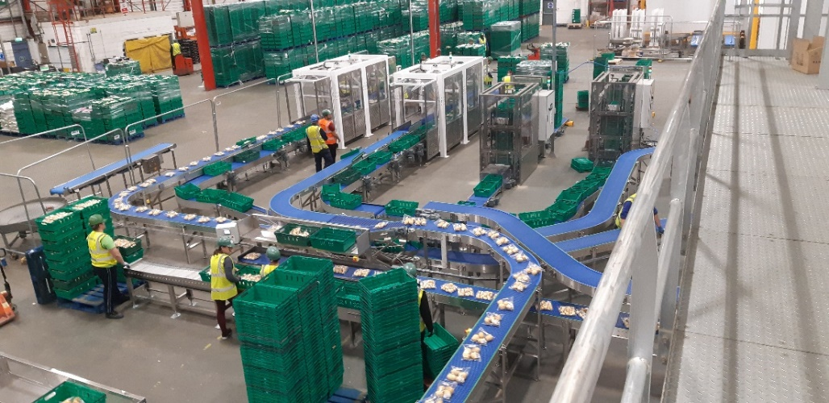

**Image 2**

**David Jahn, Director at Brillopak**

**Press release issued for Brillopak by GloHouse Media**

Lucy Benbow T +44 (0) 7971 987761 E [lucy.benbow@glohouse.co.uk](mailto:lucy.benbow@glohouse.co.uk)

# About Brillopak

Brillopak is a British manufacturer of highly flexible robotic packing and palletising systems. Using the latest proven technologies our automation solutions are designed to raise the bar in packing efficiency. All machines are small footprint and are simple to operate by unskilled staff. We have an uncompromising approach to machine safety and prioritise our design process towards minimal maintenance requirement to maximise machine uptime.  Brillopak was founded in 1999 and its machines are designed and built at our factory in Tonbridge, Kent in the United Kingdom.

**For UK media enquiries please contact:**

David Jahn, Director

Tel: 01622 872907

Email: info@brillopak.co.uk

[www.brillopak.co.uk](http://www.brillopak.co.uk)