The State of Global Ocean Freight
November 2021

December 20, 2021

Summary

- Port congestion is still impacting supply chains in North America and Europe in the run-up to the holiday season
- Container dwell times are improving slightly, but export dwell times are overall higher than import dwell times
- Significant fluctuations in global container TEU capacity will continue throughout 2021, but with noticeable shortages in the second half of the year
- January-September 2021: Clear upward trend in container rollovers, but it’s too early to interpret the October dip

Port congestion occurs when ships arrive outside a port, ready to commence cargo operations, but no berth is available. Consequently, the ships are required to wait at anchorage, or a holding area specified by a port within its limits until berths become available.

As more and more ships join the queue, congestion at a port will worsen. Port congestion has become an increasingly serious problem in the past few months. The chart below shows how it has impacted five key ports.

[See the chart on the next page]

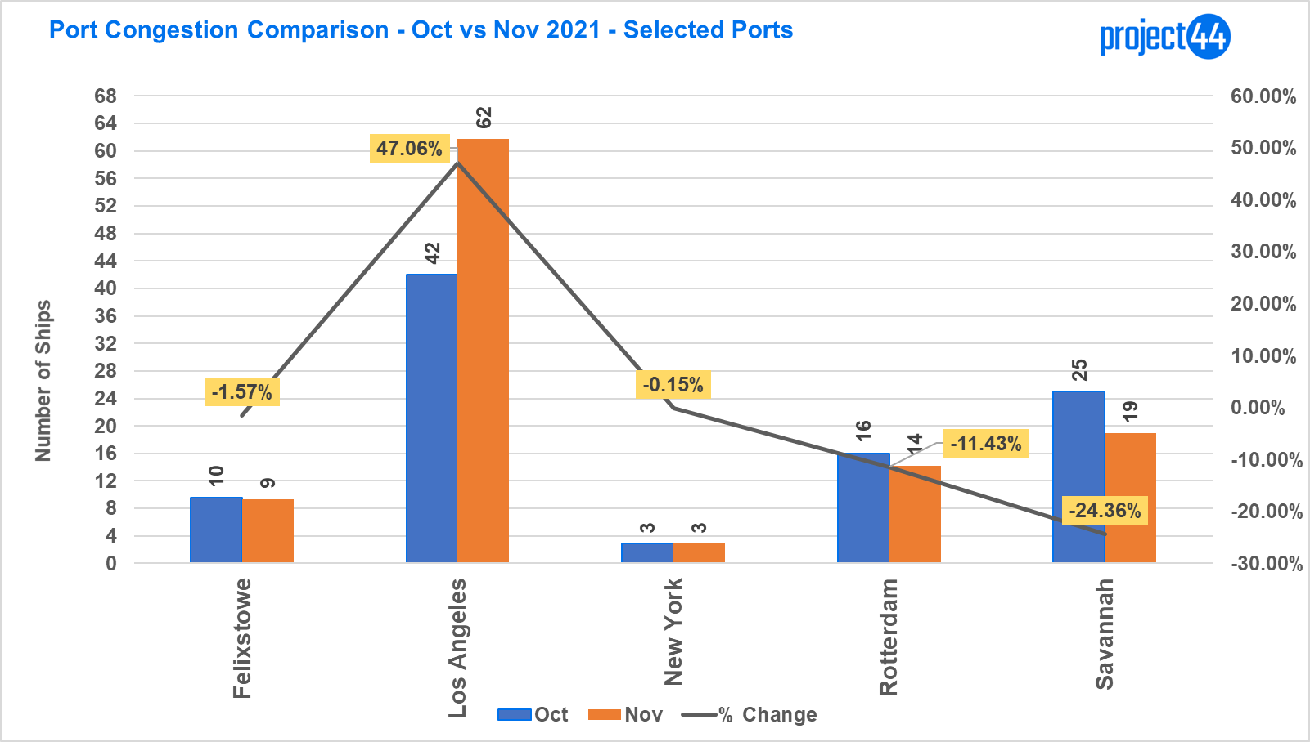

Although the situation is improving somewhat in Britain’s No. 1 container port Felixstowe, in Rotterdam, Europe’s leading container port, and in Savannah, one of the most important ports on the US East Coast, port congestion is still particularly bad at the US port complex of Los Angeles/Long Beach, which accounts for 40% of US imports.

To measure Los Angeles congestion, we use a generous 80 nautical mile (92 miles) radius out from the port on anchored container ships and with vessels a <5 knots speed. November’s drop in the number of vessels queueing near San Pedro Bay would suggest a reduction in vessel traffic, however, with the recent changes to the vessel queuing system at San Pedro Bay to reduce smog emissions near the city, many container ships (approx. 50 as of Dec 15) are now slow steaming much further off the coast of Southern California and Baja, Mexico.

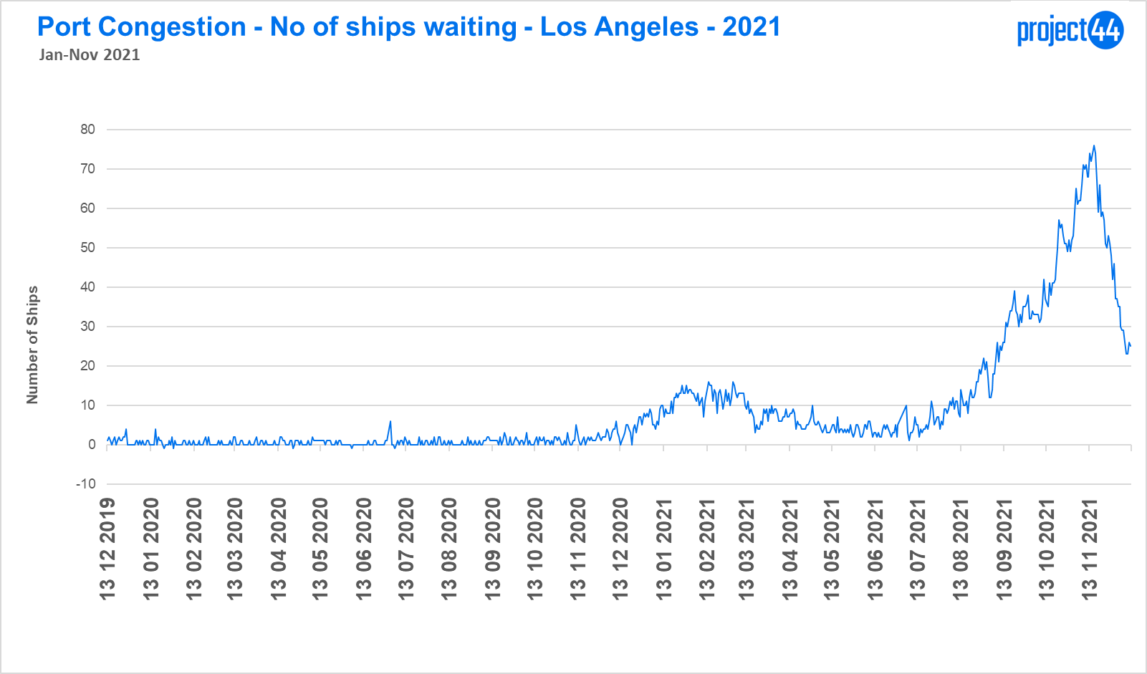

The North America West Coast congestion problem was exacerbated by severe flooding that cut all major road and rail links between the Port of Vancouver and inland destinations in Canada and the US in mid-November. The resulting port congestion in this key British Columbia port meant it made no sense for vessels heading from Asia to the West Coast of North America to re-route to Vancouver.

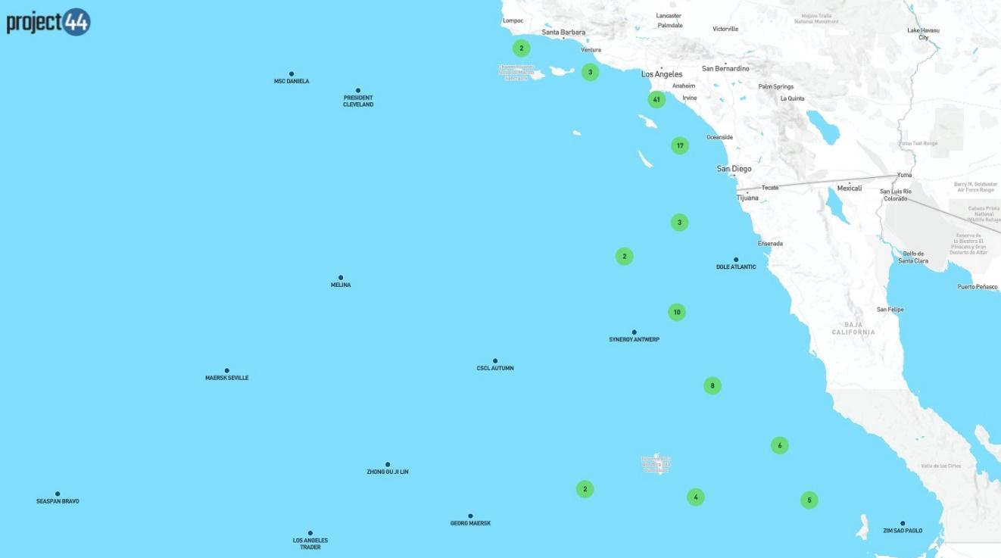

The cumulative effects of the congestion are impacting the North American and European retail sectors in the run-up to the holiday season, particularly as a large proportion of Christmas gifts are manufactured in Asia. However, the longer-term and ultimately more serious impact of this port congestion is on the just-in-time manufacturing methodology that has become the dominant production philosophy in recent decades. More on this in our next Monthly Data Update.

Container Dwell Times

Container dwell time measures the time that:
- An import container spends in port between being discharged from a vessel and leaving the port for delivery to customers;
- An export container spends in port between arriving at that port and being loaded onto a vessel.

Export and import container dwell time data for November 2021 revealed improvements in over 50% of the ports tracked compared to October 2021.

Except for Vancouver (for reasons explained above), export container dwell times fell by three days in the major ports of Felixstowe, Yantian by two days, and Hong Kong and Savannah by one day.

Four ports saw import container dwell times fall between October and November: Felixstowe by two days and Hong Kong, Shanghai, and Yantian by one day. Here, too, the exception to the rule was Vancouver for reasons explained above.

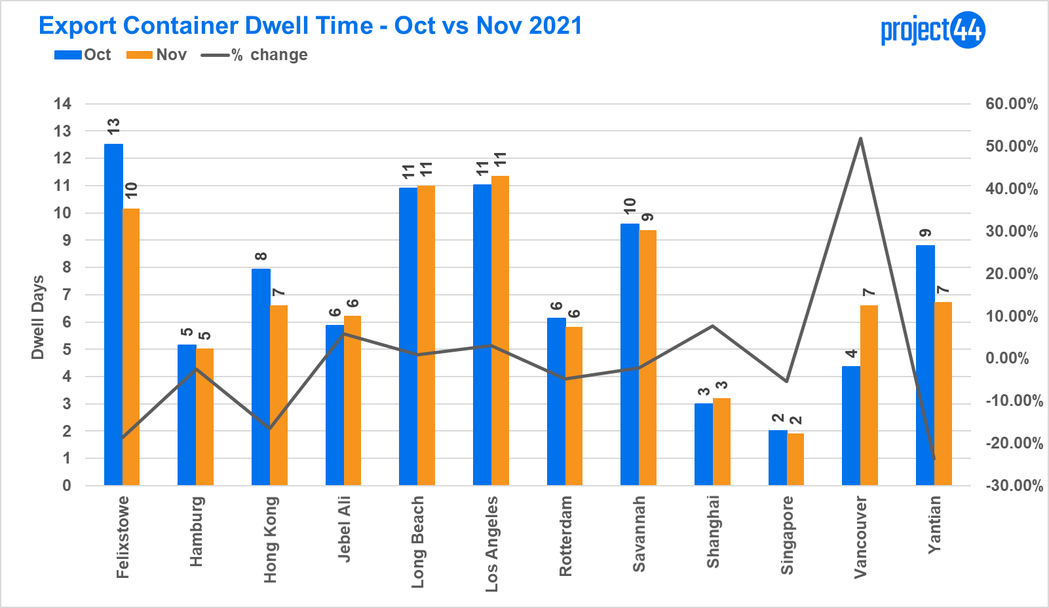

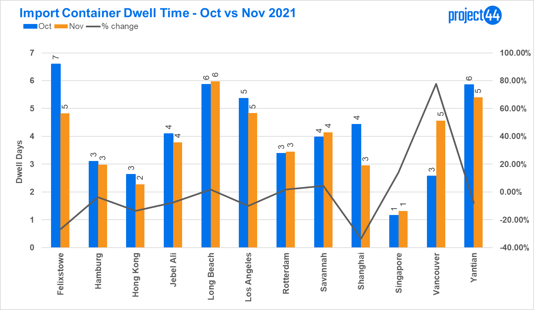

However, it must be noted that with the exception of Shanghai, export container dwell times in all these major ports were higher than import container dwell times, and in some cases, the export figure was more than twice as high. The reason why the majority of export dwell

times are higher is because of the urgent need to deliver Asian-made goods to their destinations in time for Christmas resulted in import containers being given preferential treatment. That, coupled with ballooning port congestion, means that ships were not able to berth on time to load export containers.

Another contributing factor is linked to the berthing congestion described above, which meant the ships did not arrive in time to pick up export containers that had been delivered at the port for loading on a particular ship.

Port Vessel Capacity

project44 also tracks the TEU capacity of the vessels calling at the above listed ports. Singapore had the highest number in TEU terms due to the number of services and ultra-large container vessels (ULCVs) calling there, and its status as the world’s leading transhipment hub. The chart below reveals significant fluctuations in tracked vessel TEU capacity at the 12 main global ports over the year in 2021.

[See the chart on the next page]

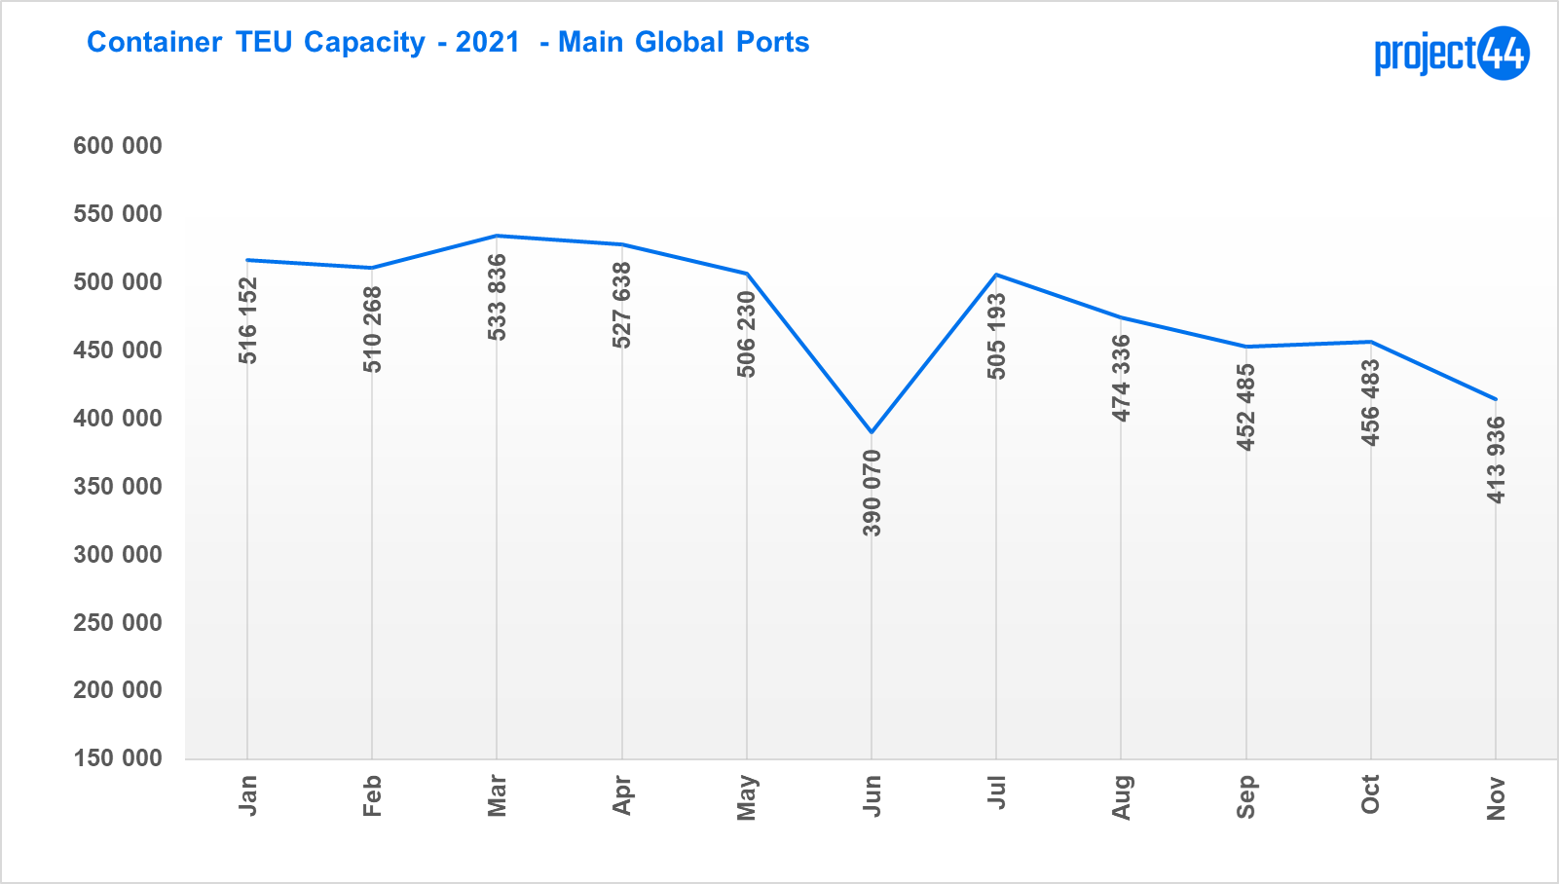

The noticeable fall-off in global vessel capacity in June and between September-November period underlines the statements frequently made by shippers that container capacity is currently in short supply globally and container freight rates are consequently going through the roof.

Container Rollovers

Container rollovers happen for a variety of reasons and the numbers depicted are not necessarily a reflection of the quality of a specific carrier’s or port’s operations. Of all transshipped containers, rollover percentages are based on the number of containers that were loaded onto a vessel other than the initially planned vessel. They are therefore not necessarily a reflection of a specific port’s capability or performance.

[See the chart on the next page]

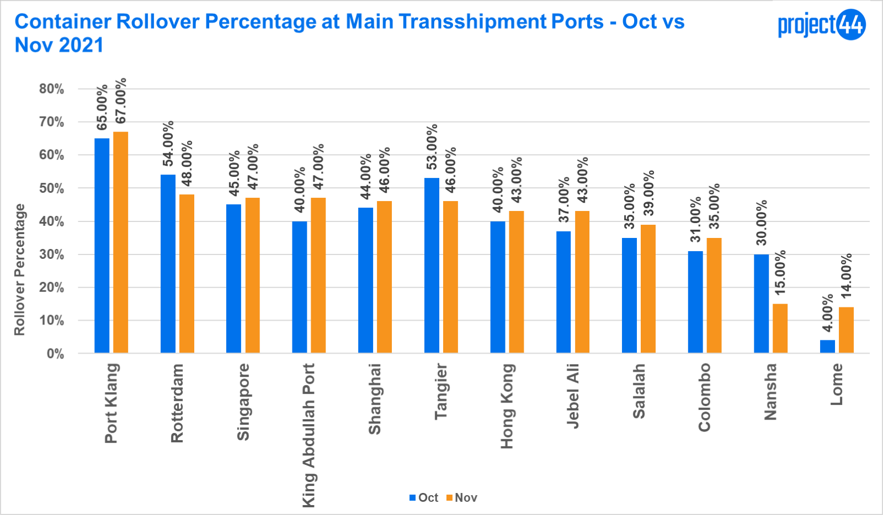

In October and November, all the major transhipment ports displayed high levels of container rollovers. This may be linked to the blank sailings that, in turn, may have been caused by berthing congestion across a variety of ports worldwide. What is clear from the data project44 has collected throughout 2021 is that there was an overall upward trend in rollover percentages from January to September. One can assume that this increase in rollovers had a lot to do with the difficult conditions experienced over this period. Ports in China, for example, suffered from various Covid-related disruptions in Q2/2021, while several major ports in North America and Europe were hit by severe congestion from August onwards.

It is too early to say whether the decline in October and slight increase in November indicate any reversal of the general upward trend in 2021. Our next Monthly Ocean Data Update will indicate whether these two months are of any longer-term significance.

[See the chart on the next page]

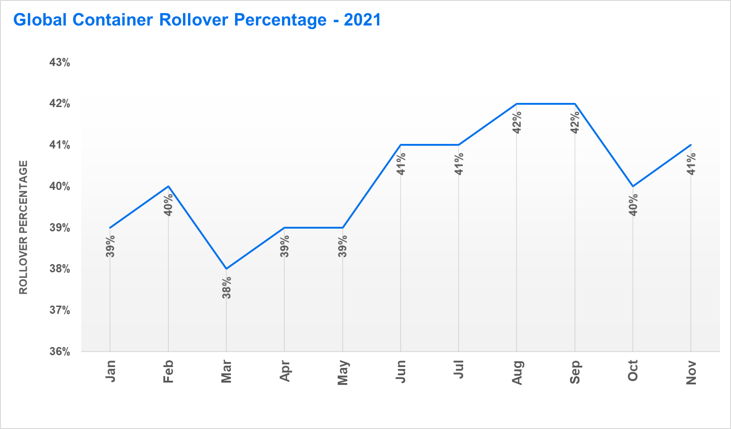

Outlook

Although new Covid outbreaks in Europe threaten return-to-normal consumer purchasing patterns, most economists and industry leaders anticipate a drop in consumer goods demand following the peak 2021 retail season. China will also shutter manufacturing for two weeks starting in February to celebrate Lunar New Year, providing carriers a brief opportunity to regroup and for ports to clear their backlogs. With looming inflation, record-high household debt levels in the US, and consumer sentiment falling to its lowest level in a decade, continued strong demand for goods into 2022 does not appear too likely.

Disclaimer: The data referenced in this release is sourced from project44’s freight visibility platform, based on the logistics indicators that the platform tracks. The sample data sets referenced do not include all freight movement data tracked by other entities. Data from project44’s platform reflects a statically significant sample size to draw conclusions.

For any questions or comments please contact
Josh Brazil – jbrazil@project44.com
Director, Supply Chain Data Insights

For media queries please contact
Charlie Pesti – charlie@pesti.io

